**Variable buttons**

Use up to 5 buttons to assign values to a Qlik Sense variable

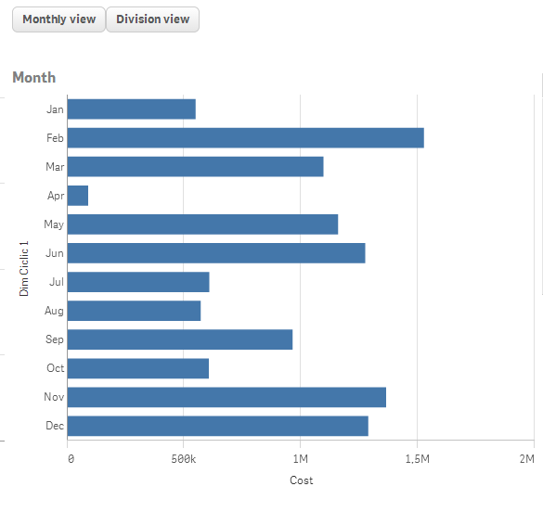

**Properties:**

**Variable to use**- Set the variable name to be used (Default: vButtonValue)

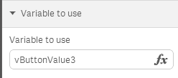  
**Number of buttons** – Number of buttons to be used (Default: 1 – Max: 5)

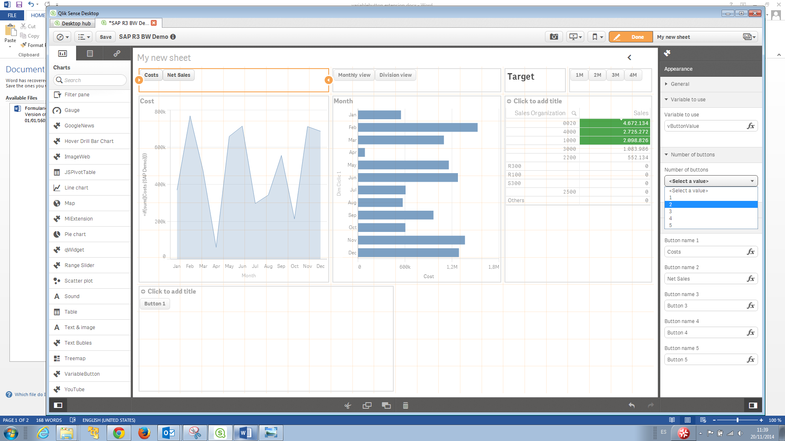  
**Button Values** - The value set per button (Default: 1,2,3,4,5)

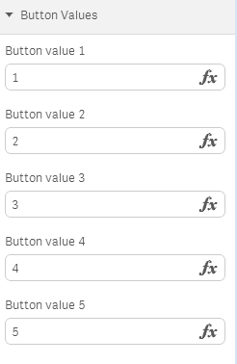  
**Button Names** - The legend to show per button (Default: Button 1, Button 2..)

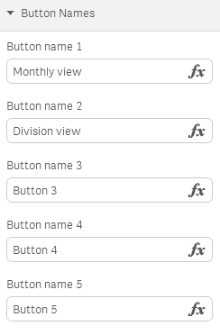

**Latest Version**

Version 0.1.0 based on Qlik Sense 1.0

**Where**

Use the variable in Qlik Sense expressions to;

-Dynamically change the expression of a graph

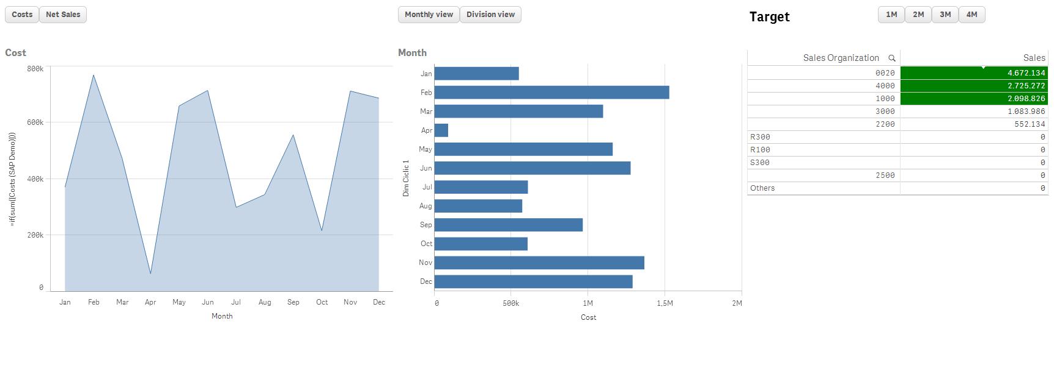

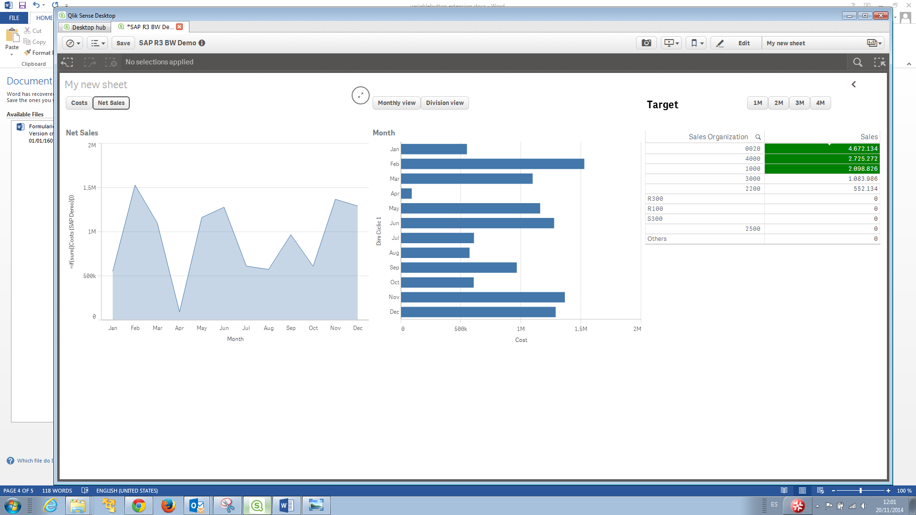

*Expression formula: if(vButtonValue=1,sum([Costs (SAP Demo)]),Sum([Net value]))*

-Dynamically change the dimension of the graph



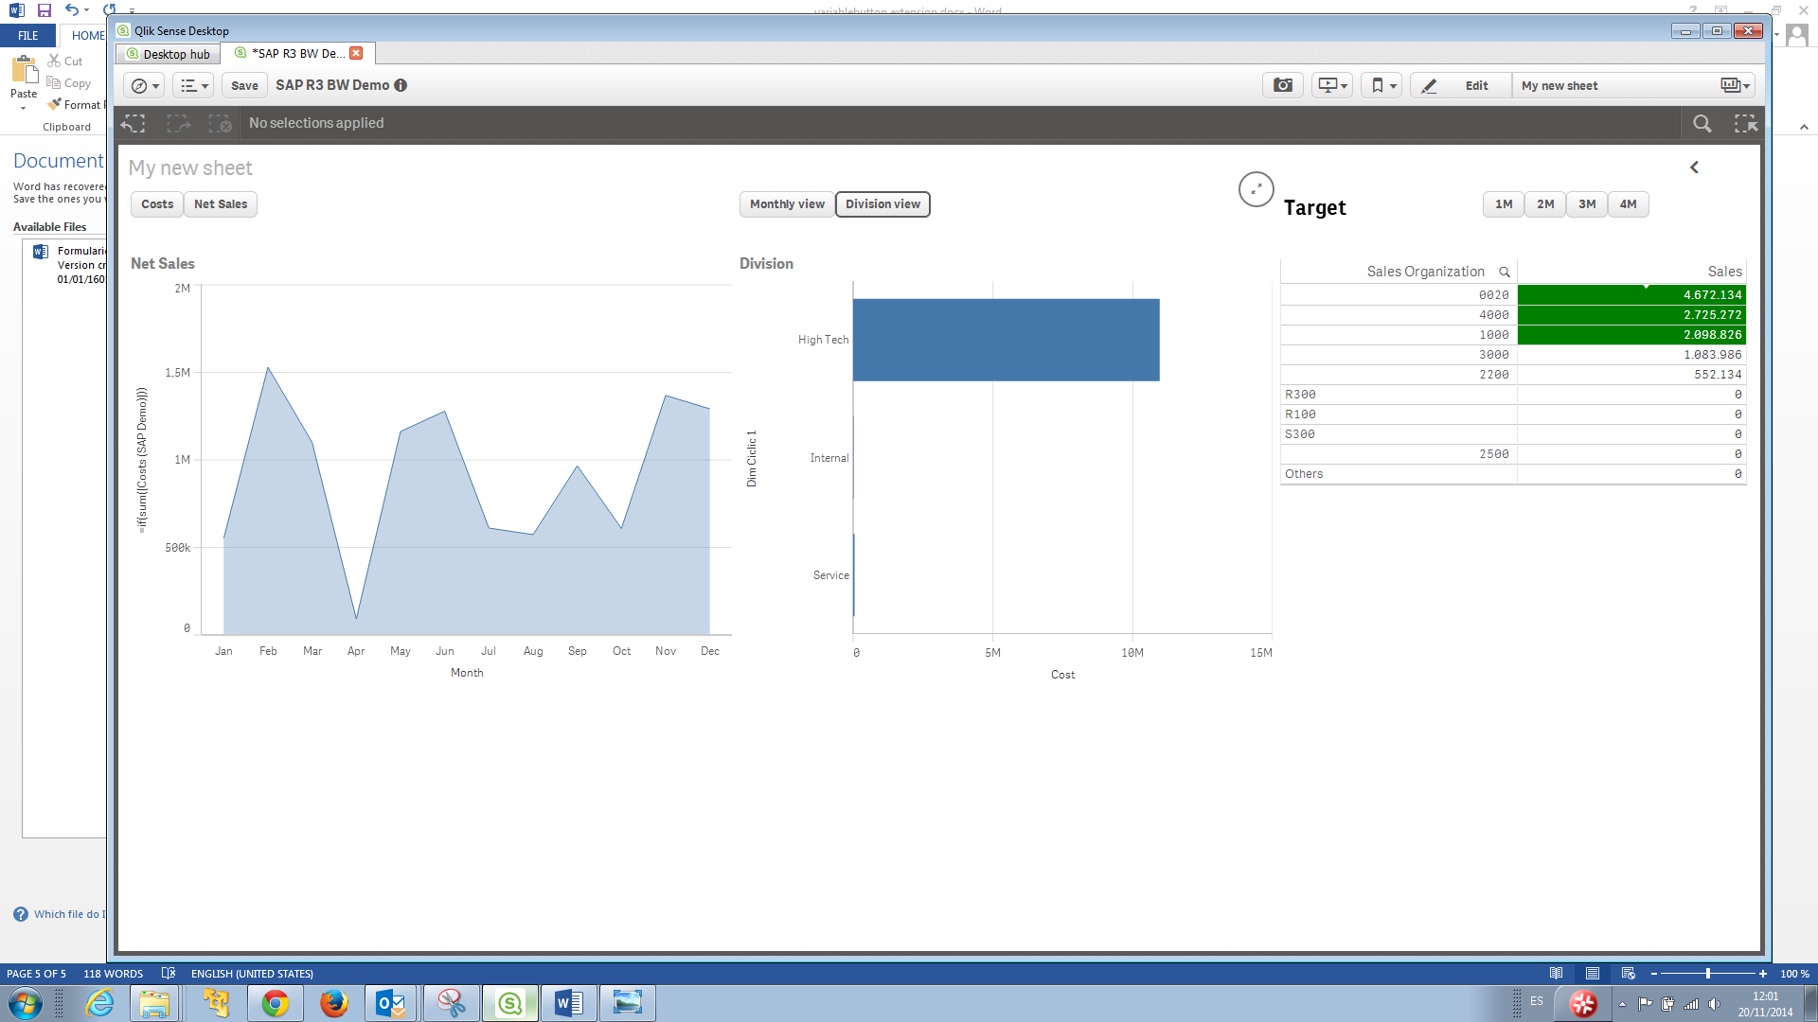

*Dimension formula: if($(vButtonValue2)=1,[Month],[Division Name])*

-Use the dimension for comparisons



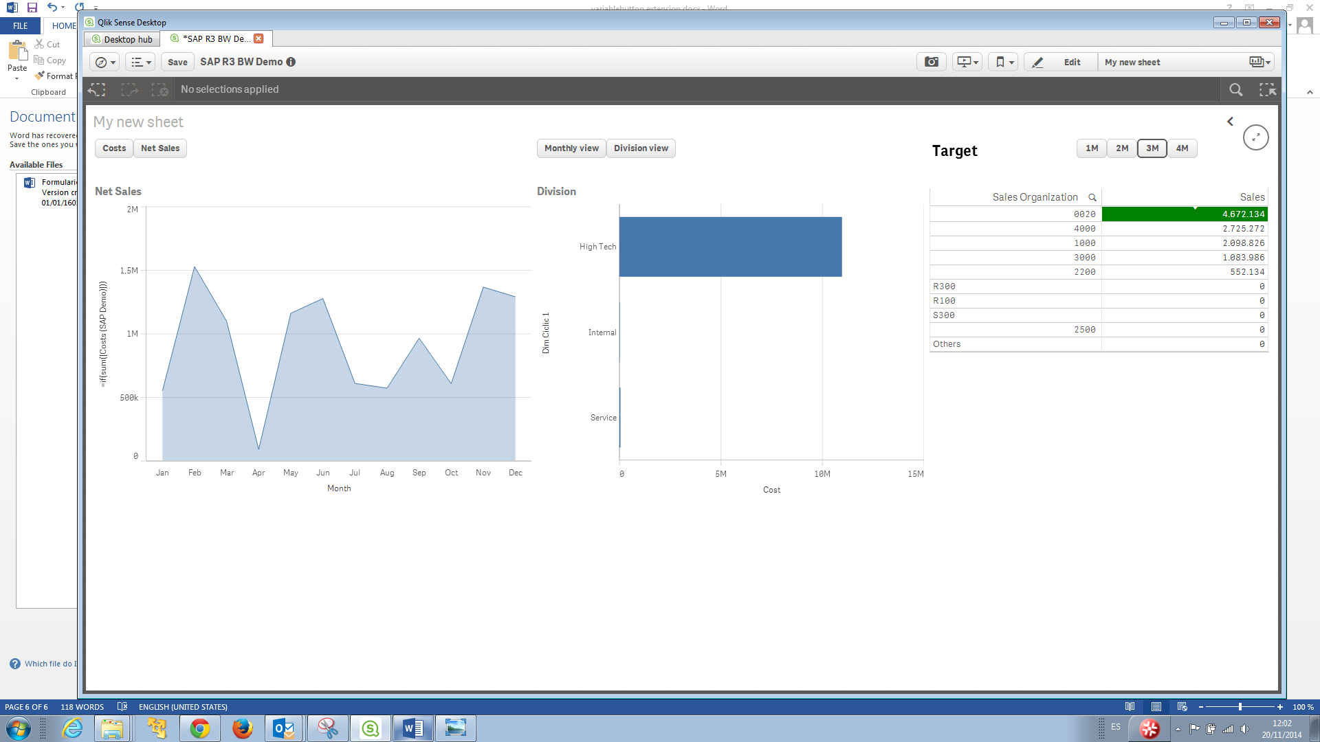

*Background color expression: if(Sum([Net value])>$(vButtonValue3),green())*

-Anywhere a variable could be used..